**QUESTION 1**

1. **Which of the following is reasonable about the meme below?**

|  |  |  |
| --- | --- | --- |
|  |  | It is a causal argument: the upper text is the premise and the lower text is the conclusion. |
|  |  | It is a non-argument: both the upper text and the lower text are facts. |
|  |  | It is the woman's explanation, not an argument. |
|  |  | It is a a valid argument from definition even though the two texts are not completely written. |

**5 points**

**QUESTION 2**

1. A survey was recently given to all high school students in a certain town to measure the effect of environmental factors on attitudes and behavior, and the results indicated that students who play a minimum of two hours per day of violent video games are more likely to engage in violent behavior in school and at home. Therefore, I can assume from this survey result that playing violent video games causes violence among teenagers.

**Which of the following is reasonable about the text about?**

|  |  |  |
| --- | --- | --- |
|  |  | It is a report, not an argument. |
|  |  | It is a deductive argument from definition. |
|  |  | It is a strong inductive generalization. |
|  |  | It is an inductive argument from authority. |

**5 points**

**QUESTION 3**

1. Ảnh có chứa văn bản, hình vẽ, bản phác thảo, minh họa

   Mô tả được tạo tự động

**Which of the following is the speaker's assumption?**

|  |  |  |
| --- | --- | --- |
|  |  | Salary rise will be lower than price rises of gas and rice. |
|  |  | Price inflation of some necessity goods has overtaken salary rise. |
|  |  | Salary rise decides the prices of gas and rice. |
|  |  | Gas and rice are necessity goods but salary is not. |

**5 points**

**QUESTION 4**

1. **Which of the following is the most reasonable about the picture below?**

|  |  |  |
| --- | --- | --- |
|  |  | It is a case of *cultural subjectivism*. |
|  |  | It may lack *completeness,*which causes a lack of *clarity.* |
|  |  | The whole text is a true fact. |
|  |  | It is a case of *warranted assumption*. |

**5 points**

**QUESTION 5**

1. The Hanks Manufacturing Company has been receiving complaints about the quality of its products and customer service. To eliminate these complaints, the Hanks' operations director has decided to adopt a quality assurance program similar to that of the Winks.

**Which of the following is an assumption of the Hanks' operations director?**

|  |  |  |
| --- | --- | --- |
|  |  | Products of the Winks are of the top quality despite its poor customer service. |
|  |  | The Winks' quality assurance program can boost customers' satisfaction. |
|  |  | The Hanks should learn the quality production programs from the Winks. |
|  |  | Quality control is the most important element for both the Hanks and the Winks. |

**5 points**

**QUESTION 6**

1. **Which of the following is the most reasonable about the meme below?**

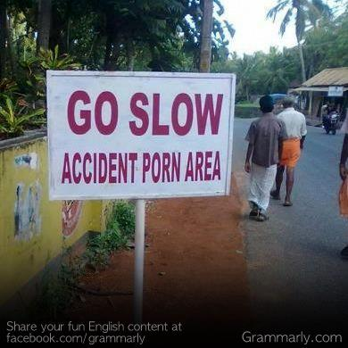

|  |  |  |
| --- | --- | --- |
|  |  | This instruction lacks either *relevance*or *logical correctness*; probably "porn" is misspelled from "prone". |
|  |  | This is not a case of *stereotype*; it's a true fact judging from the people in the picture. |
|  |  | "GO SLOW" is a non-argument. |
|  |  | "Accident" needs to be accurately written as "Accidental". |

**5 points**

**QUESTION 7**

1. **Which of the following is reasonable about the meme below?**

|  |  |  |
| --- | --- | --- |
|  |  | Ohthtz Lottie makes an inductive generalization based on the caption as a premise. |
|  |  | The caption is NASA's argument from analogy comparing a meteor with a baby elephant. |
|  |  | Ohthtz Lottie's text is a factual statement. |
|  |  | The Jesusalem Post makes an argument from authority (NASA). |

**5 points**

**QUESTION 8**

1. **Which of the following is reasonable about the picture below?**

|  |  |  |
| --- | --- | --- |
|  |  | Grumpy commits *cultural relativism*. |
|  |  | Grumpy's text can be understood as a factual statement: "These people are from another universe." |
|  |  | The text "Sorry... met" is a hypothethical argument. |
|  |  | The text "I hate... strangers" is a case of *self-serving bias.* |

**5 points**

**QUESTION 9**

1. **Which of the following is reasonable about the email below?**

|  |  |  |
| --- | --- | --- |
|  |  | It is an inductive argument from generalization. |
|  |  | It is a deductive predictive argument. |
|  |  | This argument can be evaluated as *strong* or *sound*. |
|  |  | The text "I hope... quantum mechanics" is an unsupported assertion. |

**5 points**

**QUESTION 10**

1. A person is identified as a Covid-19 F1 after he/she has been exposed to a virus carrier in a closed space, at a distance of less than 2 meters, or has such physical contact as shaking hands or kissing. An just met and hugged her Covid-infected sister at the airport. It logically follows that An is a Covid-19 F1.

**Which of the following is NOT correct about the text above?**

|  |  |  |
| --- | --- | --- |
|  |  | The whole text is an argument from definition. |
|  |  | “It logically follows that”is an induction indicator. |
|  |  | “An just met and hugged her Covid-infected sister at the airport” is a minor premise. |
|  |  | The first sentence is a general premise in a deductive argument. |

**5 points**

**QUESTION 11**

1. **Which of the following is NOT reasonable about the picture below?**

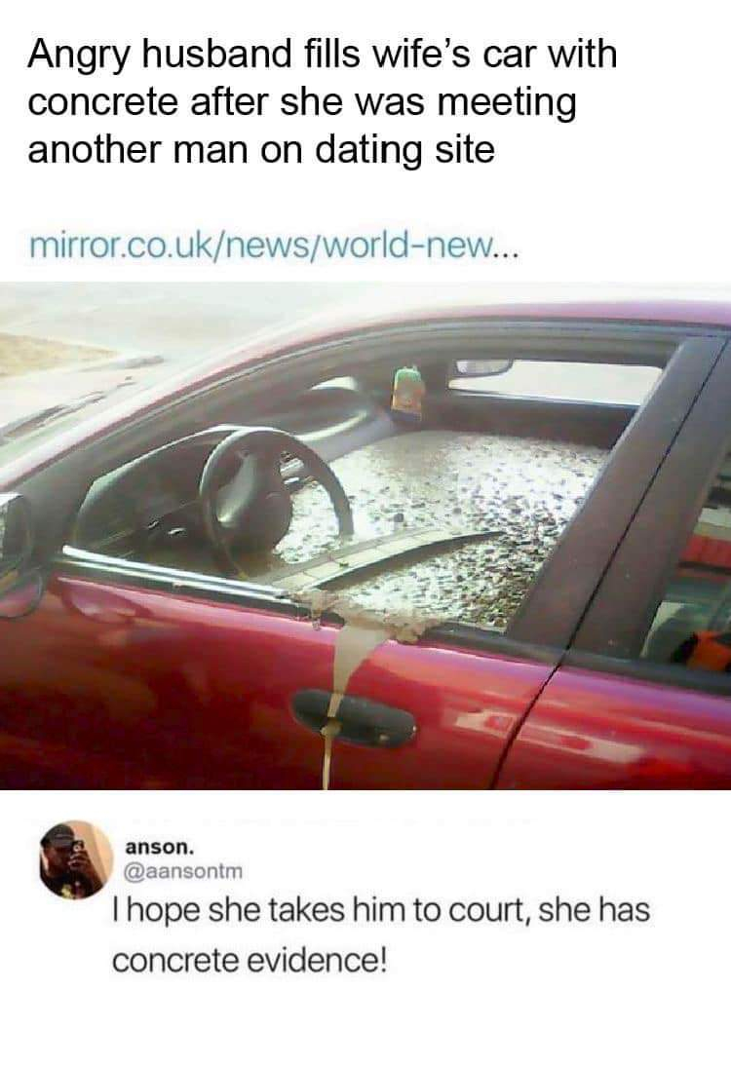

|  |  |  |
| --- | --- | --- |
|  |  | The text "Angry husband... dating site" is a report. |
|  |  | Anson makes a causal argument. |
|  |  | "Angry husband fills wife's car with concrete" is a factual statement. |
|  |  | "I hope she'll take him to court" is the non-statement. |

**5 points**

**QUESTION 12**

1. **Which of the following is TRUE about the picture below?**

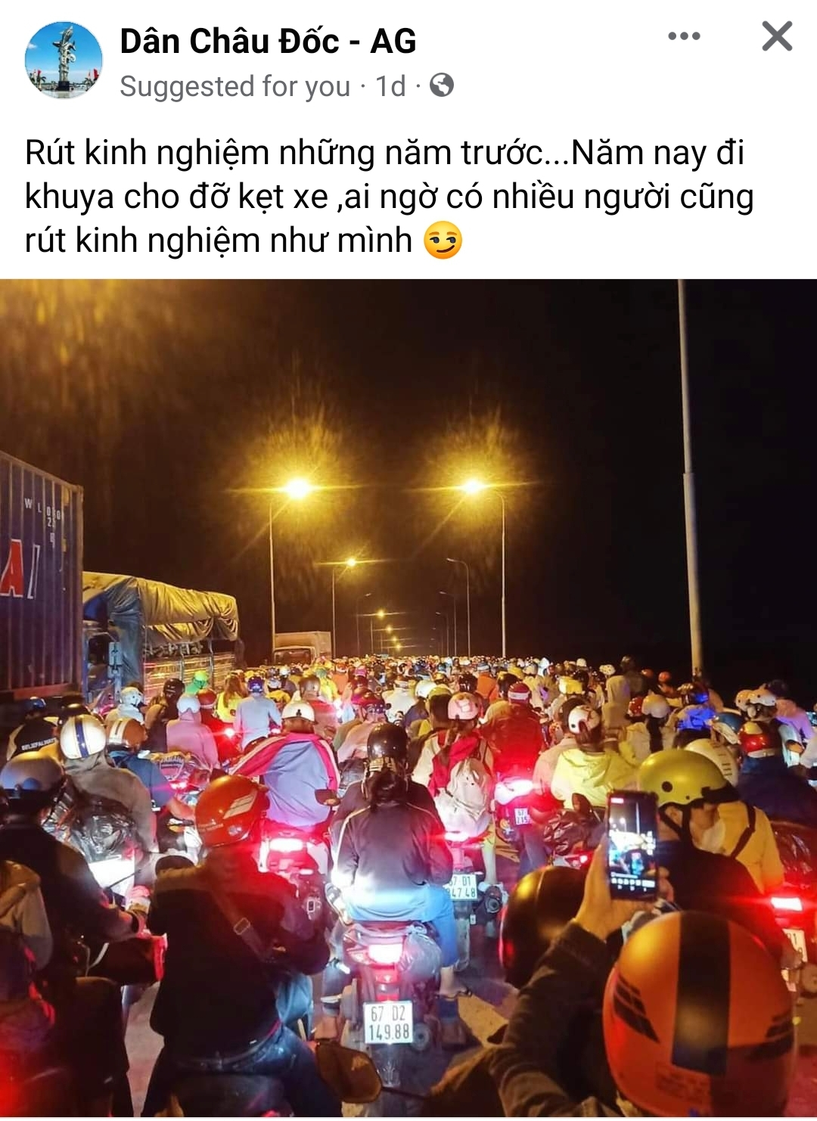

|  |  |  |
| --- | --- | --- |
|  |  | "Năm nay đi khuya cho đỡ kẹt xe" is an unwarranted assumption. |
|  |  | "Rút kinh nghiệm những năm trước" is the conclusion. |
|  |  | "Ai ngờ nhiều người cũng rút kinh nghiệm như mình" is a case of *wishful thinking*. |
|  |  | The whole text is an argument from generalization. |

**5 points**

**QUESTION 13**

1. **Which of the following is resonable about the meme below?**

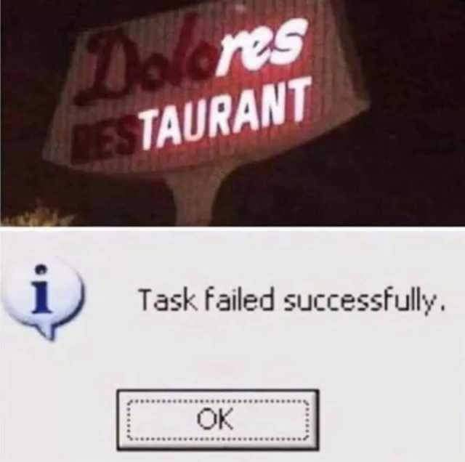

|  |  |  |
| --- | --- | --- |
|  |  | Linguistically, "Task failed successfully." lacks *logical correctness*. |
|  |  | The whole billboard can be treated as a statement. |
|  |  | The first line in the billboard is a premise. |
|  |  | The whole meme is a causal argument and "Task failed successfully" is its strong conclusion. |

**5 points**

**QUESTION 14**

1. **Which standard of critical thinking may be missing in the following meme?**

|  |  |  |
| --- | --- | --- |
|  |  | Logical correctness |
|  |  | Practical consistency |
|  |  | Fairness |
|  |  | Accuracy |

**5 points**

**QUESTION 15**

1. **Which of the following is TRUE of the picture below?**

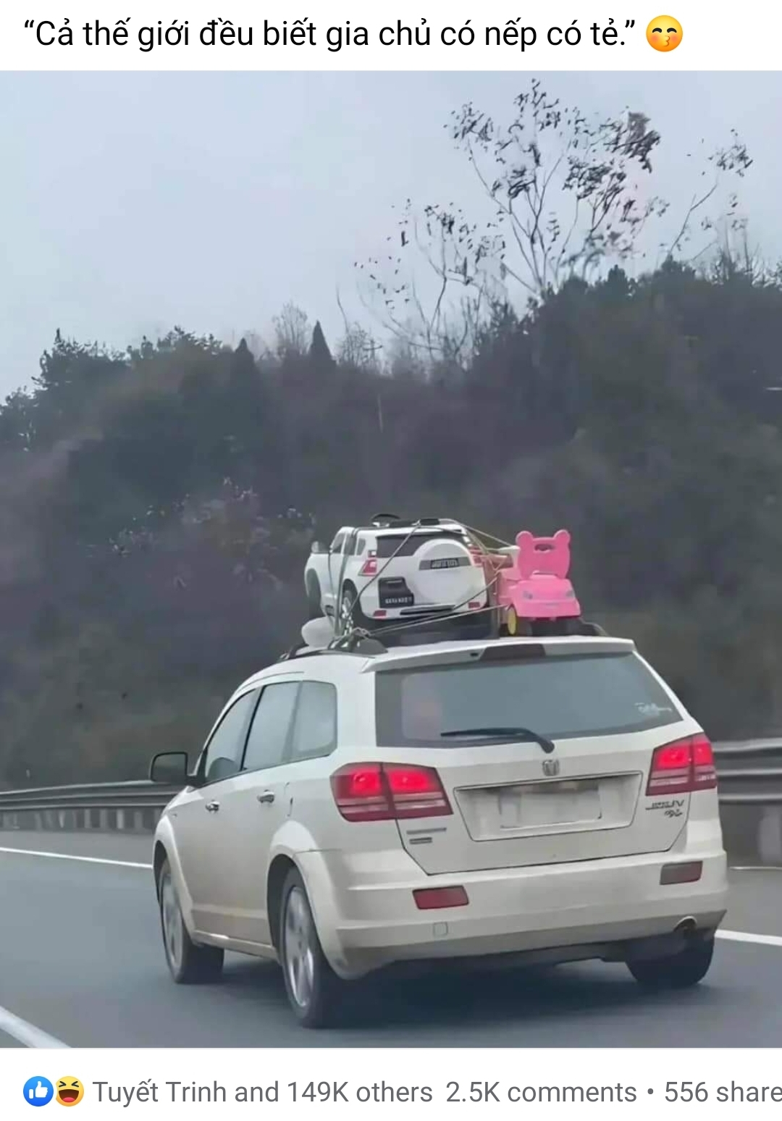

|  |  |  |
| --- | --- | --- |
|  |  | From the page administrator's perspective, the toy cars are gender stereotypes. |
|  |  | The text "Cả thế giới đều biết gia chủ có nếp có tẻ" only is an argument from generalization. |
|  |  | The picture is the premise and the caption is the conclusion of a predictive argument. |
|  |  | There is a hypothetical argument: "If the car driver carries a white toy car and a pink toy car, he/she must have a son and a daughter." |

**5 points**

**QUESTION 16**

1. A marriage counselor noted that couples who have occasional violent arguments are less likely to divorce within the next six months than those who have frequent but less violent arguments. He concluded that frequent arguing is a major factor leading to unhappy or broken marriage.

**This argument pattern is a/an ______.**

|  |  |  |
| --- | --- | --- |
|  |  | inductive causal argument |
|  |  | inductive argument from authority |
|  |  | deductive argument from definition |
|  |  | inductive argument from generalization |

**5 points**

**QUESTION 17**

1. **Which of the following is TRUE of the picture below?**

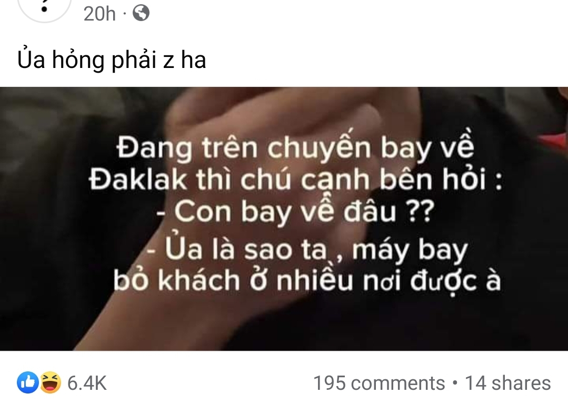

|  |  |  |
| --- | --- | --- |
|  |  | The question "Con bay về đâu?"  lacks ***accuracy*** in the wording. |
|  |  | "Ủa là sao ta"  is an exclamation, so it's a non-argument. |
|  |  | Structurally, "máy bay bỏ khách ở nhiều nơi được à" is a statement. |
|  |  | The whole text is a report, so it is a non-statement. |

**5 points**

**QUESTION 18**

1. **Which of the following is TRUE of the following picture?**

|  |  |  |
| --- | --- | --- |
|  |  | Teresa Giudice's post is a case of *stereotype*. |
|  |  | Teresa Giudice commits *inconsistency*. |
|  |  | Teresa Giudice's post lacks *precision*. |
|  |  | Teresa Giudice's post is an *illustration*. |

**5 points**

**QUESTION 19**

1. If we do Quiz 1 in the evening, we'll have more comfort to focus better. We have more comfort to focus better. So we do Quiz 1 in the evening.

**This argument ______.**

|  |  |  |
| --- | --- | --- |
|  |  | affirms the antecedent and it is valid |
|  |  | denies the antecedent and it is invalid |
|  |  | affirms the consequent and it is invalid |
|  |  | denies the consequent and it is valid |

**5 points**

**QUESTION 20**

1. **Which of the following is the best assumption in the speech?**

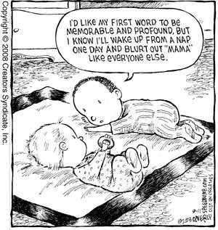

|  |  |  |
| --- | --- | --- |
|  |  | Mother is the dearest or closest to everyone. |
|  |  | No babies can memorize their first word. |
|  |  | "Mama" is not a profound word to babies. |
|  |  | "Mama" cannot be spoken clearly after a baby's nap. |

**5 points**

**QUESTION 21**

**Which of the following is reasonable about the image below?**

|  |  |  |
| --- | --- | --- |
|  |  | The pictures are premises and the caption is the conclusion of an argument from generalization. |
|  |  | It is a valid and sound deductive argument from mathematics. |
|  |  | The caption is a true premise; all the pictures make an interesting conclusion. |
|  |  | It has four unwarranted assumptions in the pictures and a true premise in the caption. |

**5 points**

**QUESTION 22**

1. ‘Nearly all places of interest, especially tourist cities, were packed during the past holiday. Da Lat is a famous city of interest. It can be inferred that Da Lat was packed during the past holiday.

**Which of the following is reasonable about the given text?**

|  |  |  |
| --- | --- | --- |
|  |  | It is a report, not an argument. |
|  |  | It is a valid and sound argument. |
|  |  | It is a hypothetical syllogism. |
|  |  | It is a strong and cogent argument. |